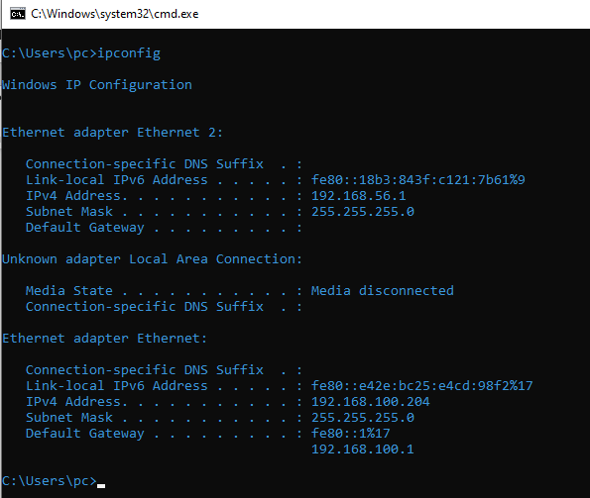

**(5)**

* **Host Name**: The name of the computer on the network.
* **IPv4 Address**: A unique 32-bit address that identifies the device on a local network.
* **IPv6 Address**: A longer 128-bit address to support a larger number of devices than IPv4.
* **Subnet Mask**: Defines the network portion of the IP address.
* **Default Gateway**: The IP address of the router or gateway that connects the local network.
* **DNS Servers:** IP addresses of servers used for web browsing.
* **MAC Address**: Helps identify and authenticate devices on the network, commonly used for access control and troubleshooting.
* **DHCP**: Indicates if the system receives its IP configuration automatically from a DHCP server.

**(4)** 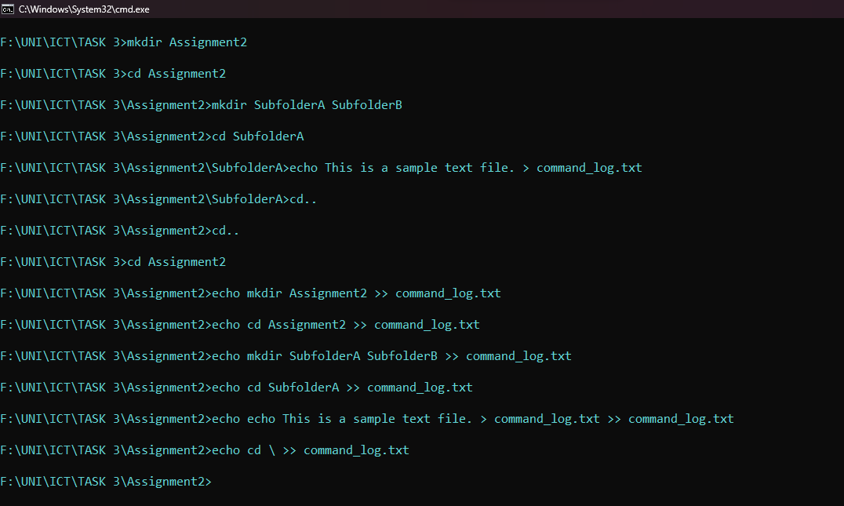

**ALL COMMANDS USED:**

$$mkdir Assignment2$$

$$cd Assignment2$$

$$mkdir SubfolderA SubfolderB$$

$$cd SubfolderA$$

$$echo This is a sample text file. > command_log.txt$$

$$cd..$$

$$cd..$$

$$cd Assignment2$$

$$echo mkdir Assignment2 >> command_log.txt$$

$$echo cd Assignment2 >> command_log.txt$$

$$echo mkdir SubfolderA SubfolderB >> command_log.txt$$

$$echo cd SubfolderA >> command_log.txt$$

$$echo echo This is a sample file. ^> example.txt >> command_log.txt$$

$$echo cd \backslash >> command_log.txt$$